**PSY 653 Module 8: Mediation Practice**

**Gemma Wallace & Neil Yetz**

**April 1, 2020**

**Demo Activity**

1. Create a new R notebook and load the following libraries: tidyverse, psych, ppcor & mediation (Note: you will need to download the mediation package)
2. Read in the datafile “mediate2.csv”
3. For all of the models specified below, conduct the following steps to test for the presence of mediated relationships
   1. Examine the correlations among these three variables. Do not perform any additional analyses beyond calculating these correlations.
   2. Using the Baron & Kenny criteria, is it even plausible that a mediated relationship might be present? Describe your reasoning in answering this question.
   3. Based on what you see in this correlation matrix, do you think this hypothesis is likely to be supported or not. Describe your reasoning in answering this question.
   4. Calculate the semipartial correlation between Y and X holding the relationship between X and M. What conclusions do you reach about the mediation hypothesis?
   5. Use the regression method to test the mediation hypothesis. Describe the analyses you performed and the conclusions you reached
   6. Use the mediate function in “psych”. To evaluate the mediation hypothesis
      1. What is critical to look at in this output?
      2. What does it tell you?
      3. What conclusions do you reach about mediation?
   7. Use the mediate function in “mediation”
      1. What is critical to look at in this output?
      2. What does it tell you?
      3. What conclusions do you reach about mediation?
4. Analysis 1: Test the hypothesis that X4 mediates the relationship between X1 and Y1
5. Analysis 2: Test the hypothesis that X4 mediates the relationship between X3 and Y1
6. Analysis 3: Test the hypothesis that X4 mediates the relationship between X5 and Y1

**Try it yourself activity**

The following activity will use the datafile “slpdata.csv.”

*Description of the dataset:*

A team of sleep researchers sought to study the effects of a 6-week sleep intervention aimed to improve participant’s sleep hygiene. Sleep hygiene encompasses a variety of practices and habits that are necessary to have good nighttime sleep quality and full daytime alertness. The team formulated three different versions of the intervention. The first version (condition 1) provided participants with a self-help book on the topic of sleep hygiene. The second version (condition 2) brought participants together once per week in groups of 10-12 to teach the principles of sleep hygiene in a classroom setting. The final version (condition 3) also used the group-based classroom setting of condition 2, but in addition, each participant’s partner was invited to also take part in the group sessions. Six-hundred male and female adults living with an intimate partner and suffering from a sleep disorder were recruited to take part in the study, the participants were randomly assigned to one of the three conditions. The data set includes the following variables:

* sex: 1=male, 2=female
* age: Participant’s age in years
* anxiety: Participant’s level of general anxiety measured at the start of the study via a multi-item scale. The scale (average of all items) ranges from 1 to 7, where a higher score indicates a higher level of anxiety.
* prior: An indicator of whether or not the participant had previously participated in some type of sleep intervention, 1 = yes, 0 = no.
* hygiene: Participant’s sleep hygiene at week 6. It ranges from 0 to 10, and higher means better sleep practices.
* support: Participant’s perception that their partner is supportive of their struggles with sleep and their efforts to improve sleep. It is a multi-item scale that ranges from 1 to 5, where higher indicates more support.
* sleep: Participant’s average sleep efficiency during the month following the intervention, calculated as time spent in bed asleep (minus all the awakenings), divided by the total time spent in bed. It is expressed as a percentage.
* lifesat: Participant’s sense of life satisfaction measured 30 days after the completion of the intervention. It is a multi-item scale that ranges from 1 to 7, where a higher score indicates more satisfaction.
* cond: Treatment condition, 1 = self-help, 2 = group-based intervention, 3 = group-based plus partner participation.

Use the mediation analyses steps covered in the demo activity to conduct the following analyses:

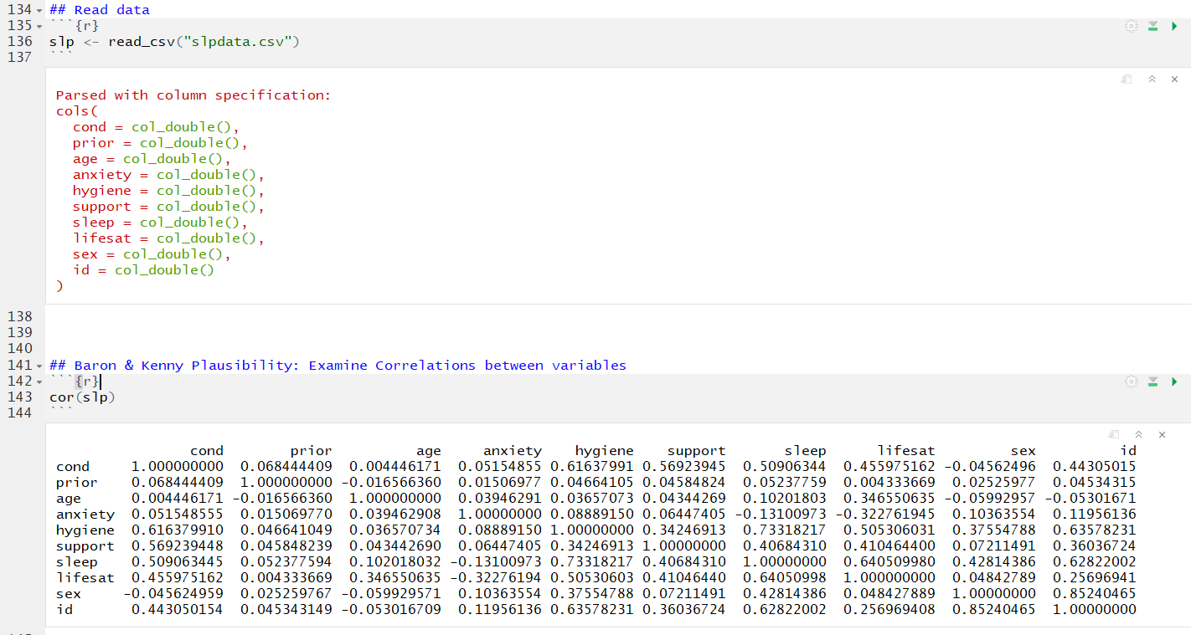

1. Test the hypothesis that sleep efficiency mediates the relationship between sleep hygiene and life satisfaction.

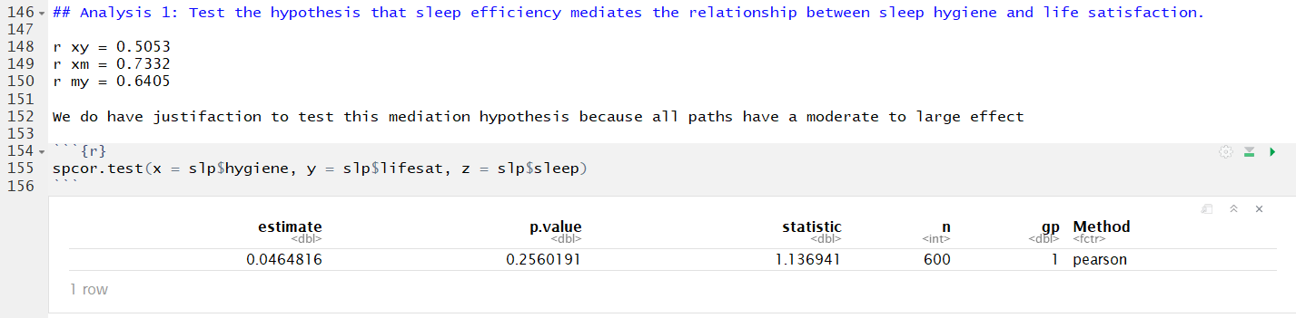

r y(x.m) = 0.0464. This is 0.12 smaller than r xy (0.5053), indicating that partial mediation is plausible. In other words, there is a portion of the relation betweeen x and y that involves m.

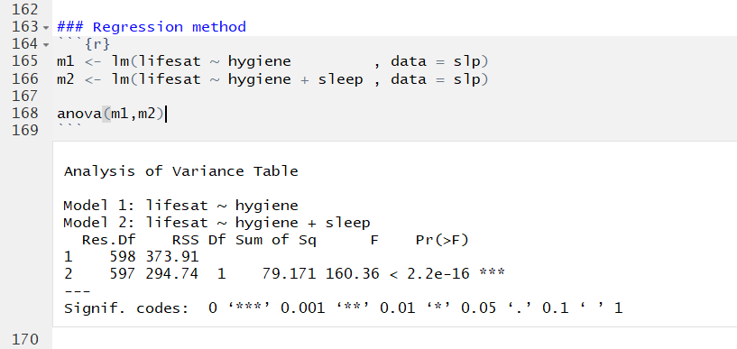

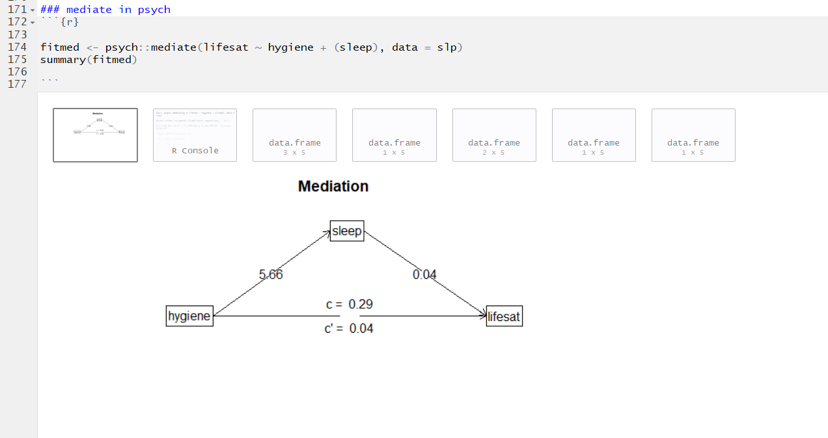

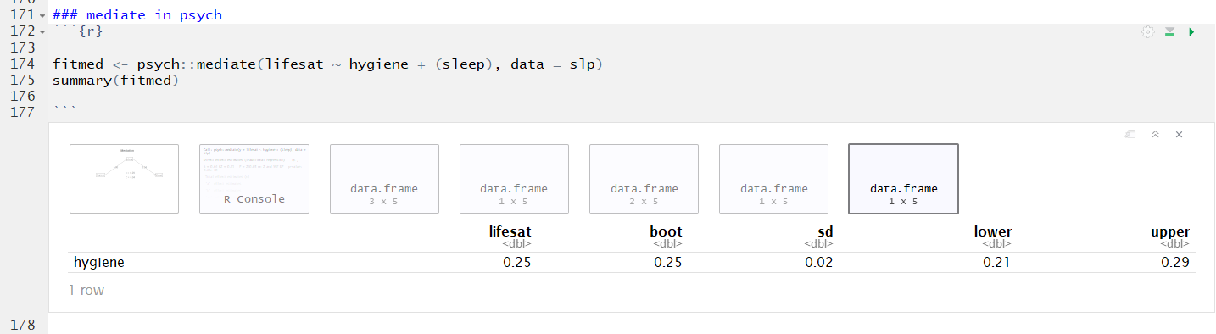

Results from psych::mediate indicate that we have significant partial mediation. The bootstrapped indirect effect (a*b) is .25 and the confidence intervals do NOT contain zero.

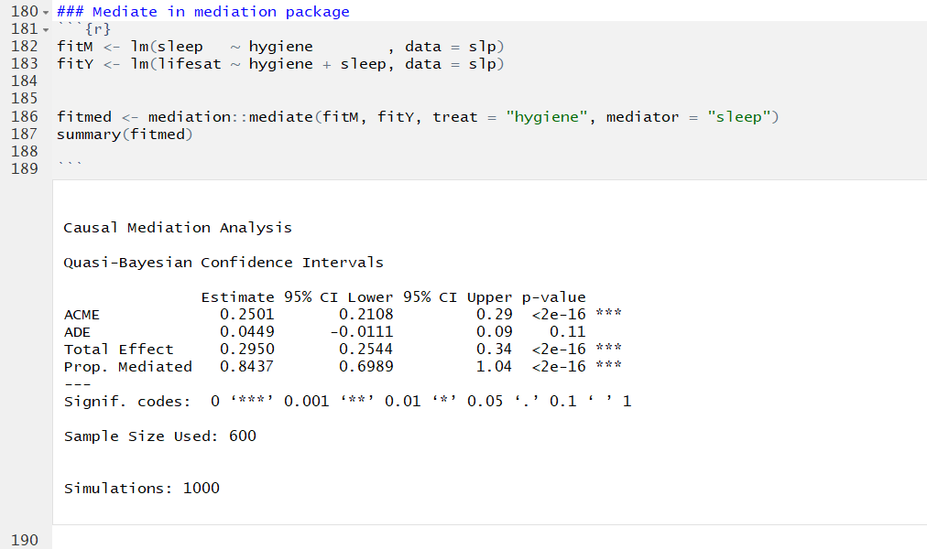

Results from medation::mediate provide similar results to psych::mediate. 84.37% of the effect hygiene to lifesat is mediated by sleep.

1. Test the hypothesis that sleep efficiency mediates the relationship between anxiety and life satisfaction.

